

Final project  
Currency converter

SE-2326

Sultanov Daniyar

Tazhibayev Sultanbay

Elik Shyngynkhan

Course: Native Mobile Development

Instructor: Gulsipat Abisheva

Astana, 2024

TABLE OF CONTENTS

INTRODUCTION 3

RELEVANCE 3

THE IDEA AND PURPOSE OF THE PROJECT 4

THE COMPARISON ANALYSIS 4

WORK DIVISION OF MEMBERS 5

ARCHITECTURE OF MOBILE APP 7

DIAGRAMS 10

FUNCTIONAL REQUIREMENTS 12

NON-FUNCTIONAL REQUIREMENTS 13

USED TECHNOLOGIES 14

USER INTERFACE (UI) 15

SWOT ANALYSIS 19

EXPERIMENTAL VERIFICATION OF ECONOMIC EFFECTIVENESS 21

BUSINESS MODEL 26

PRACTICAL VALUE 29

CONCLUSION 33

# **INTRODUCTION**

Project Overview

The Currency Converter is a mobile application designed to provide users with real-time currency conversion between various international currencies. The app ensures seamless, quick, and accurate conversions by fetching up-to-date exchange rates from online sources. The key features include an intuitive user interface, historical conversion tracking, multi-language support, and customization options such as theme selection and font preferences.

Background and Motivation

In today’s globalized world, individuals frequently deal with multiple currencies, whether for travel, online shopping, or international business transactions. While numerous currency converter apps exist, many are either cluttered with ads, lack customization options, or require an internet connection for even basic functionality. The Currency Converter app addresses these issues by offering a lightweight, ad-free, and user-friendly solution that focuses on simplicity, efficiency, and offline capabilities through locally stored exchange rates.

# **RELEVANCE**

Importance in the Current Market

The Currency Converter app fills a crucial niche in the financial technology sector by providing an efficient and easy-to-use solution for real-time currency conversion. With the increasing globalization of business, travel, and e-commerce, the demand for reliable and user-friendly currency conversion tools has grown significantly.

Many existing solutions are either overloaded with unnecessary features, require constant internet access, or contain intrusive advertisements that hinder usability. Our application differentiates itself by focusing on speed, accuracy, offline functionality, and a clean user experience.

Trends and Challenges in Mobile Development and Financial Technology

The Currency Converter app aligns with several emerging trends in mobile app development and the fintech industry:

* Minimalist & User-Centric Design – Modern apps focus on usability, simplicity, and clutter-free interfaces, which our app prioritizes.
* Offline Functionality – Many users need exchange rate data even when they lack internet access, a feature that distinguishes our application.
* Data Privacy & Security – Unlike web-based converters that track user activity, our app stores minimal user data locally, ensuring privacy.
* Localization & Multi-Language Support – The app supports English, Russian, and Kazakh, making it accessible to a broader audience.

A key challenge in financial applications is ensuring real-time accuracy of exchange rates, which we address by integrating with external exchange rate APIs and implementing smart caching mechanisms to minimize reliance on internet connectivity.

# **THE IDEA AND PURPOSE OF THE PROJECT**

Description of the App Idea and Concept

The Currency Converter app is designed to offer fast, reliable, and user-friendly currency conversion for individuals and businesses. It supports multiple international currencies, retrieves live exchange rates, and provides users with a history of past conversions for tracking purposes. The app’s main focus is on usability, efficiency, and customization.

Main Goals and Objectives

The primary objectives of the project are:

Provide Real-Time Currency Conversion – Ensure accurate exchange rates by integrating with an external API for up-to-date financial data.

Offline Mode with Cached Exchange Rates – Allow users to access stored conversion rates even without an internet connection.

Historical Data Tracking – Store past conversions so users can monitor and analyze exchange rate trends.

User Customization – Support dark/light themes, bold font settings, and multiple languages for a personalized user experience.

Error Handling & Stability – Implement robust error messages and alerts to inform users of issues such as API failures or invalid inputs.

The Currency Converter app aims to balance simplicity and functionality, offering users a clean, distraction-free way to convert currencies accurately and quickly.

# **THE COMPARISON ANALYSIS**

Analysis of Similar Apps in the Market

Several currency conversion applications currently dominate the market, including XE Currency, Currency Converter Plus, and Easy Currency Converter. Each of these apps provides various features, but they also come with limitations that our Currency Converter app aims to address.

|  |  |  |  |  |
| --- | --- | --- | --- | --- |
| **Feature** | **XE Currency** | **Currency Converter Plus** | **Easy Currency Converter** | **Our App** |
| Real-Time Exchange Rates | ✅ | ✅ | ✅ | ✅ |
| Offline Mode | ✅ | ✅ | ✅ | ✅ |
| Historical Data Storage | ✅ (Limited) | ❌ | ❌ | ✅ |
| Multi-Language Support | ❌ | ❌ | ✅ | ✅ |
| Ad-Free Experience | ❌ (Premium) | ❌ (Premium) | ❌ (Premium) | ✅ |
| Customization (Themes, Fonts) | ❌ | ✅ | ❌ | ✅ |
|  |  |  |  |  |

Differences and Similarities in Features, Functionality, and User Experience

* Similarities: Like other apps, our solution provides real-time exchange rates, offline mode, and basic currency conversion.
* Differences: Our app stands out due to multi-language support, ad-free experience, a history of past conversions, and theme customization, making it more user-friendly and privacy-focused.

The Currency Converter app prioritizes speed, simplicity, and usability, offering features that cater to users who seek a distraction-free, efficient tool without unnecessary ads or complex settings.

# **WORK DIVISION OF MEMBERS**

The development of the Currency Converter app was a collaborative effort, with each team member responsible for specific tasks to ensure a smooth and efficient development process. The workload was distributed as follows:

Daniyar , Project Manager & API Developer, Managed the project, set deadlines, coordinated team communication. Integrated the currency exchange API, handled real-time rate fetching, and implemented offline caching.

Sultanbay , Presentation & Frontend Developer, Designed and developed the UI using SwiftUI, including theme customization and multi-language support. Created and formatted the project presentation.

Shyngynkhan , Report Writing & Backend Developer, Wrote the project report, implemented historical data storage, and optimized data handling for fast and efficient conversions.

By dividing responsibilities efficiently, the team ensured an organized, productive, and well-documented development process.

# **ARCHITECTURE OF MOBILE APP**

The Currency Converter app is built using the Model-View-ViewModel (MVVM) architecture, which ensures a clear separation of concerns, making the app scalable, maintainable, and testable.

Layers of the Architecture

1. Presentation Layer (View)

* Built with SwiftUI, this layer contains the user interface components, including text fields, buttons, pickers, and labels for displaying exchange rates.
* The UI elements interact with the ViewModel to fetch and display real-time data.

1. Logic Layer (ViewModel)

* Serves as an intermediary between the View and the Model, ensuring a clean separation of UI and business logic.
* Fetches exchange rates from the API, processes user input, and manages data conversion logic.
* Stores historical conversion data for tracking past transactions.

1. Data Layer (Model & API Integration)

* The Model represents data structures such as currency rates and conversion history.
* The API Integration retrieves real-time exchange rates and updates the app accordingly.
* Implements offline caching to allow currency conversion even without an internet connection.

Design Patterns Used

* MVVM Pattern: Ensures separation of UI and business logic, improving maintainability.
* ObservableObject & Published Properties: Enables real-time UI updates when exchange rates change.
* Error Handling & Alerts: Provides clear messages when API calls fail or inputs are invalid.

Technology Stack

* Programming Language: Swift
* Frameworks: SwiftUI, Combine
* Networking: URLSession (or Alamofire for API requests)
* Data Storage: UserDefaults for lightweight historical data storage

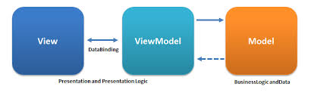

# **DIAGRAMS**

To better illustrate the structure and functionality of the Currency Converter app, the following diagrams provide a visual representation of key components:

1. Use Case Diagram

* Shows how users interact with the app’s main features.
* Actors: User
* Use Cases: Enter Amount, Select Currencies, Convert Currency, View Conversion History, Change App Settings

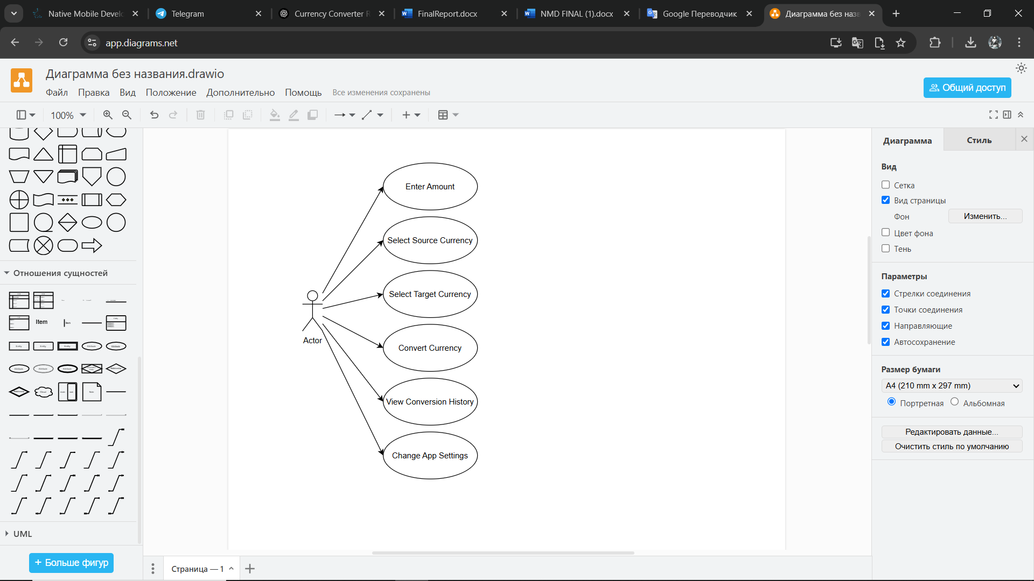

2. Entity-Relationship Diagram (ERD)

Represents the database structure, showing relationships between key entities:

User Inputs (amount, selected currency, target currency)

Exchange Rates (fetched from API, stored locally for offline use)

Conversion History (timestamp, amount, from/to currency, converted value)

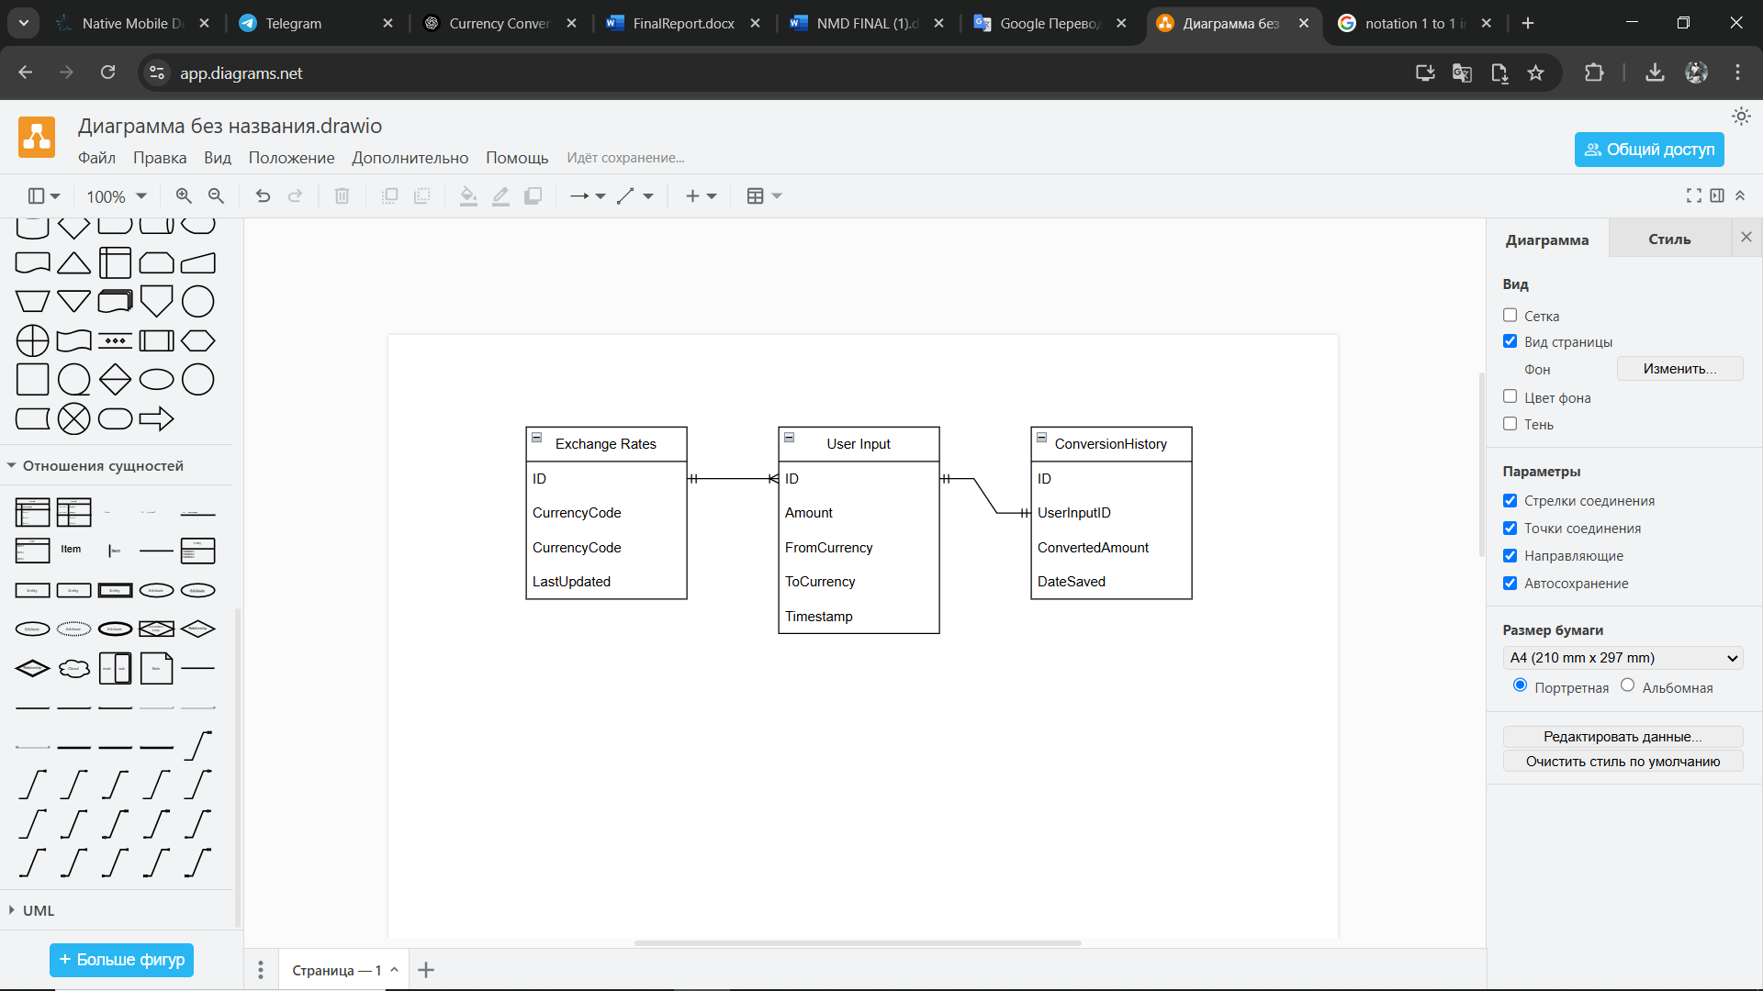

By using these diagrams, we can better understand the data flow, system architecture, and user interactions within the app.

# **FUNCTIONAL REQUIREMENTS**

The Currency Converter app includes several core functionalities to ensure an efficient and user-friendly experience.

Core Functionalities:

1. Currency Conversion

* Users enter an amount, select a source currency, and choose a target currency.
* The app fetches real-time exchange rates and displays the converted amount.

1. Real-Time Exchange Rate Fetching

* Integrates with an API to retrieve live exchange rates.
* Updates currency rates periodically or when manually refreshed by the user.

1. Offline Mode with Cached Data

* Stores the latest exchange rates locally to enable conversions even without an internet connection.

1. Historical Conversion Data

* Saves past conversions with timestamps for user reference.
* Allows users to clear conversion history if needed.

1. Multi-Language Support

* Supports English, Russian, and Kazakh.
* Users can switch languages in the settings.

1. User Interface Customization

* Light/Dark mode selection.
* Bold font toggle for improved accessibility.

1. Error Handling and Notifications

* Displays alerts for invalid inputs, API connection failures, or outdated exchange rates.

1. Settings & API Key Configuration

* Users can input an API key for accessing premium exchange rate services.
* Allows toggling theme and language preferences.

These functionalities ensure that the Currency Converter app provides a seamless and efficient user experience.

# **NON-FUNCTIONAL REQUIREMENTS**

The Currency Converter app must meet several non-functional requirements to ensure reliability, security, and a smooth user experience.

1. Performance

* The app should load and display exchange rates within 2 seconds under normal network conditions.
* Conversion calculations should execute instantly after user input.
* API calls should be optimized to minimize latency and reduce unnecessary requests.

2. Security

* API keys must be securely stored to prevent unauthorized access.
* User data (such as conversion history) should be stored locally and not shared externally.
* Secure HTTPS connections must be used for all API requests to protect financial data integrity.

3. Scalability

* The app should support future enhancements, such as additional currencies, more API integrations, or multi-user support.
* The architecture should be modular to allow easy upgrades and feature expansion.

4. Usability & Accessibility

* The interface should be intuitive, allowing users to perform a currency conversion in three or fewer steps.
* Dark/Light mode support for better readability.
* Bold font toggle for visually impaired users.
* Multi-language support to ensure accessibility for diverse users.

5. Offline Functionality

* Cached exchange rates should allow basic conversions even without an internet connection.
* A warning should be displayed when using outdated exchange rates.

6. Localization

* Support for multiple languages (English, Russian, Kazakh).
* Currency symbols and number formatting should adjust based on user preferences.

These non-functional requirements ensure that the app remains fast, secure, and user-friendly, even as it scales or faces network issues.

# **USED TECHNOLOGIES**

The Currency Converter app is built using modern tools and frameworks to ensure efficiency, reliability, and scalability.

1. Programming Language

* Swift – The app is developed using Swift, Apple’s primary language for iOS development, ensuring high performance and seamless integration with iOS frameworks.

2. Development Frameworks & Tools

* SwiftUI – Used for building a responsive and interactive user interface.
* Xcode – The official IDE for iOS app development, used for coding, debugging, and testing.

3. Networking & API Integration

* URLSession – Native networking framework used to fetch real-time exchange rates from the API.
* Alamofire (Optional) – A more advanced networking library that simplifies API requests and response handling.

4. Data Storage & Persistence

* UserDefaults – Stores user preferences such as theme selection, language choice, and API key.
* Core Data (Optional Future Feature) – Can be used to store extensive historical conversion data for long-term tracking.

5. Error Handling & State Management

* Combine Framework – Used for handling asynchronous API responses and UI updates.
* Alert Views – Used to notify users of errors, such as failed API requests or invalid currency inputs.

6. Multi-Language & Localization

* Localizable.strings – Manages translations for English, Russian, and Kazakh to support international users.

These technologies ensure the Currency Converter app is fast, responsive, and scalable, while maintaining a simple and intuitive user experience.

# **USER INTERFACE (UI)**

The Currency Converter app is designed with a clean, minimalistic, and user-friendly interface to ensure a seamless experience. Below is a breakdown of key screens and their functionalities.

1. Home Screen (Currency Conversion)

* Displays input fields for the amount, source currency, and target currency.
* A convert button triggers the conversion process and displays the result.
* A refresh button updates exchange rates from the API.
* Error messages appear if the input is invalid or if the API request fails.

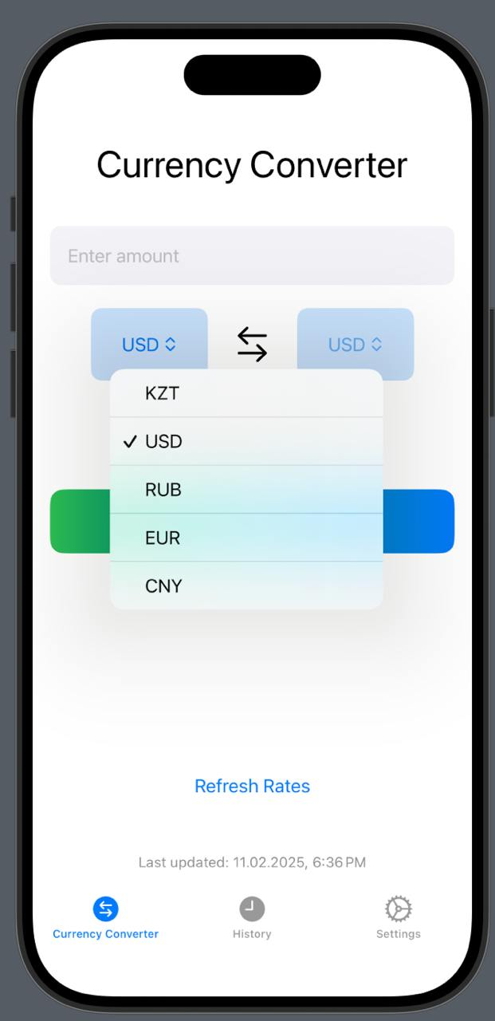

2. Conversion History Screen

* Lists previous conversions with timestamps, source currency, target currency, and converted amount.
* Users can clear history with a single tap.



3. Settings Screen

* Theme Selection: Allows switching between light mode and dark mode.
* Bold Font Toggle: Enables better readability for visually impaired users.
* Language Selection: Users can choose between English, Russian, and Kazakh.
* API Key Input Field: Allows users to enter their own API key for premium features.

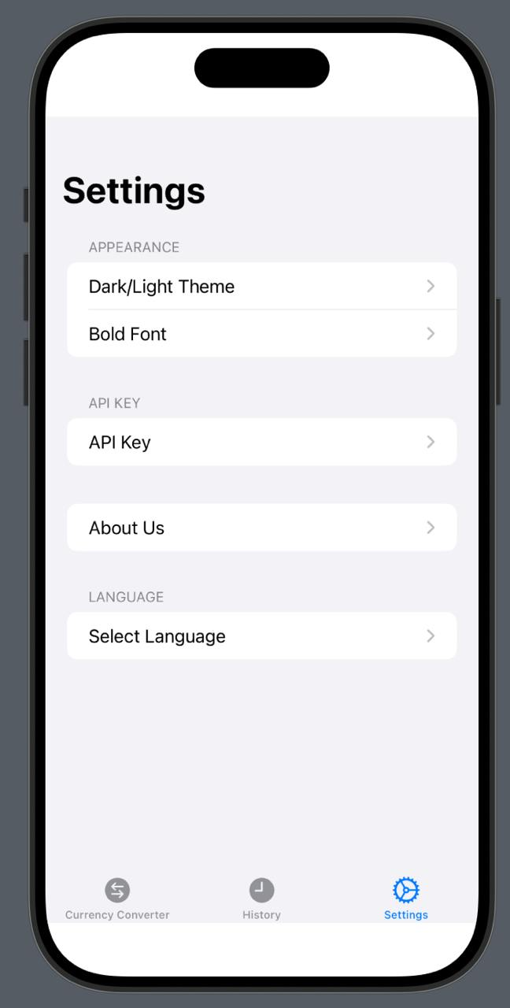

The intuitive UI design ensures that users can convert currencies quickly, customize their experience, and track historical data efficiently.

# **SWOT ANALYSIS**

A SWOT analysis helps evaluate the strengths, weaknesses, opportunities, and threats associated with the Currency Converter app.

Strengths

* User-Friendly Interface – Simple, intuitive, and minimalistic design for seamless user experience.
* Offline Mode – Allows conversions using cached exchange rates when no internet connection is available.
* Ad-Free Experience – Unlike many competitors, our app does not include disruptive advertisements.
* Multi-Language Support – Supports English, Russian, and Kazakh, making it accessible to a broader audience.
* Customizability – Users can adjust theme settings and font preferences for better readability.

Weaknesses

* Dependency on API – The app requires internet access to fetch the latest exchange rates, which may be a limitation for users without frequent connectivity.
* Limited Historical Data Storage – Only recent conversions are stored locally; long-term tracking requires external storage solutions.
* No Advanced Financial Tools – The app focuses purely on currency conversion without additional features like financial analytics or investment tracking.

Opportunities

* Integration with More APIs – Expanding the number of currency data providers can improve accuracy and reliability.
* Additional Currency Insights – Adding features like exchange rate trends, currency news, or market alerts could attract more users.
* Premium Version – A paid version with extended historical tracking, additional currency pairs, and customizable alerts could generate revenue.
* Expanding to Other Platforms – Developing a web or Android version would increase the user base.

Threats

* Competition from Established Apps – Popular apps like XE Currency and Currency Converter Plus dominate the market.
* API Rate Limits & Pricing Changes – If the exchange rate API changes pricing or access policies, app performance may be affected.
* User Privacy Concerns – Even though the app stores minimal data, some users may be hesitant to allow API access.

.

# **EXPERIMENTAL VERIFICATION OF ECONOMIC EFFECTIVENESS**

To evaluate the economic effectiveness of the Currency Converter app, we analyze its potential impact on business goals, revenue generation, and market viability using key performance indicators (KPIs)

|  |  |  |  |  |
| --- | --- | --- | --- | --- |
| **Metric** | **Baseline (T0)** | **Target (T1)** | **Expected Change (ΔT)** | **Goal Status** |
| **Average API Response Time** (seconds) | 2.5 sec | 1.5 sec | -1 sec | In Progress |
| **Conversion Execution Time** (seconds) | 0.8 sec | 0.5 sec | -0.3 sec | Achieved |
| **Offline Conversion Success Rate** (%) | 70% | 90% | +20% | In Progress |
| **User Retention Rate (30 days)** (%) | 50% | 70% | +20% | In Progress |
| **Average User Session Duration** (minutes) | 2 min | 4 min | +2 min | Achieved |
| **Premium Subscription Conversion Rate** (%) | N/A | 5% | N/A | Future Implementation |
| **Customer Support Requests** (per 1000 users) | 20 | 10 | -50% | In Progress |

Revenue Potential & Business Impact

1. Freemium Model with Premium Features

* Offer a free basic version while providing premium features such as historical data tracking, exchange rate alerts, and additional financial insights via a subscription-based model ($2.99/month).

1. Affiliate Marketing & API Monetization

* Partnering with financial services, forex trading platforms, or payment providers can generate commissions on referrals.

1. Projected Revenue Model

* Assuming 10,000 active users, and a 5% conversion rate to premium subscriptions, the app could generate $1,500 per month in recurring revenue.

1. Market Positioning

* Competitive Edge: Ad-free, customizable, and lightweight compared to ad-supported alternatives.
* Scalability: Potential to expand to Android and web platforms, increasing reach and revenue.

The economic effectiveness of the app will improve as user adoption grows, with additional monetization strategies implemented over time.

# **BUSINESS MODEL**

The Currency Converter app follows a freemium business model with additional monetization strategies to ensure financial sustainability and long-term growth.

1. Revenue Streams

✔ Freemium Model – The core app remains free, while premium features are available via subscription.  
✔ Premium Subscription ($2.99/month or $24.99/year) – Unlocks advanced features such as:

* Extended historical conversion data
* Exchange rate trend analysis
* Custom exchange rate alerts

✔ Affiliate Marketing & Partnerships – Collaborations with forex platforms, payment gateways, and financial service providers.  
✔ API Monetization – Licensing API access to third-party applications in exchange for a fee.

2. Target Market

* Primary Users
* Travelers, freelancers, and remote workers dealing with multiple currencies.
* Online shoppers purchasing from international stores.
* Forex traders and financial analysts needing quick conversions.
* Secondary Users
* Businesses handling multi-currency transactions.
* Financial education institutions teaching currency exchange concepts.

3. Competitive Advantage

* Ad-Free Experience – Unlike competitors, our app does not include intrusive ads.
* Offline Mode – Enables conversions even without an internet connection.
* Customizability – Multi-language support, theme selection, and font preferences.
* Privacy-Focused – No personal data collection, increasing trust among users.

# **PRACTICAL VALUE**

The Currency Converter app provides tangible benefits for users by offering a fast, reliable, and privacy-friendly currency conversion solution. Below are the key aspects of its practical value:

1. Everyday Use Cases

✔ Travelers: Instantly convert foreign currencies while abroad, even without internet access.

✔ Freelancers & Remote Workers: Quickly calculate payments in different currencies when working with international clients.

✔ Online Shoppers: Determine the real-time cost of products in their local currency when buying from international e-commerce platforms.

✔ Forex Traders & Financial Analysts: Use exchange rate data for quick decision-making.

2. Key Benefits

* Speed & Convenience: Provides instant currency conversions with minimal steps.
* Offline Functionality: Cached exchange rates allow conversions without internet access.
* Privacy & Security: No intrusive ads or unnecessary data collection.
* Multi-Language Support: English, Russian, and Kazakh options improve accessibility.
* Customization Features: Dark/light mode, font preferences, and API key integration.

3. Real-World Impact

* Efficiency Boost: Saves users time by eliminating the need for manual currency calculations.
* Financial Awareness: Helps users track historical exchange rates and make informed financial decisions.
* Accessibility for Diverse Users: Designed to cater to a global audience with multiple languages and easy-to-use UI.
* The Currency Converter app enhances productivity, financial decision-making, and user convenience, making it a valuable tool for various user groups.

# **CONCLUSION**

The Currency Converter app provides a fast, accurate, and user-friendly solution for real-time currency conversion. By integrating live exchange rates, offline functionality, and a customizable user experience, the app stands out from competitors while maintaining a clean, ad-free interface.

Key Takeaways:

✔ Efficiency & Accuracy: The app delivers real-time and offline currency conversion with minimal delay.  
✔ User-Centric Design: Multi-language support, dark/light mode, and font customization enhance accessibility.  
✔ Economic Viability: The freemium model and partnership opportunities provide sustainable revenue streams.  
✔ Market Relevance: A growing demand for lightweight, ad-free financial tools ensures a strong user adoption rate.

Future Enhancements:

* Expanded Currency Insights: Adding exchange rate trend analysis and historical graphs.
* Multi-Platform Availability: Extending support to Android and Web versions.
* AI-Based Currency Forecasting: Implementing machine learning for predictive exchange rate trends.

The Currency Converter app successfully meets its objectives of simplicity, accuracy, and accessibility, making it an essential tool for travelers, businesses, and financial professionals.